Deadline: Applications must be postmarked
March 1, 2017
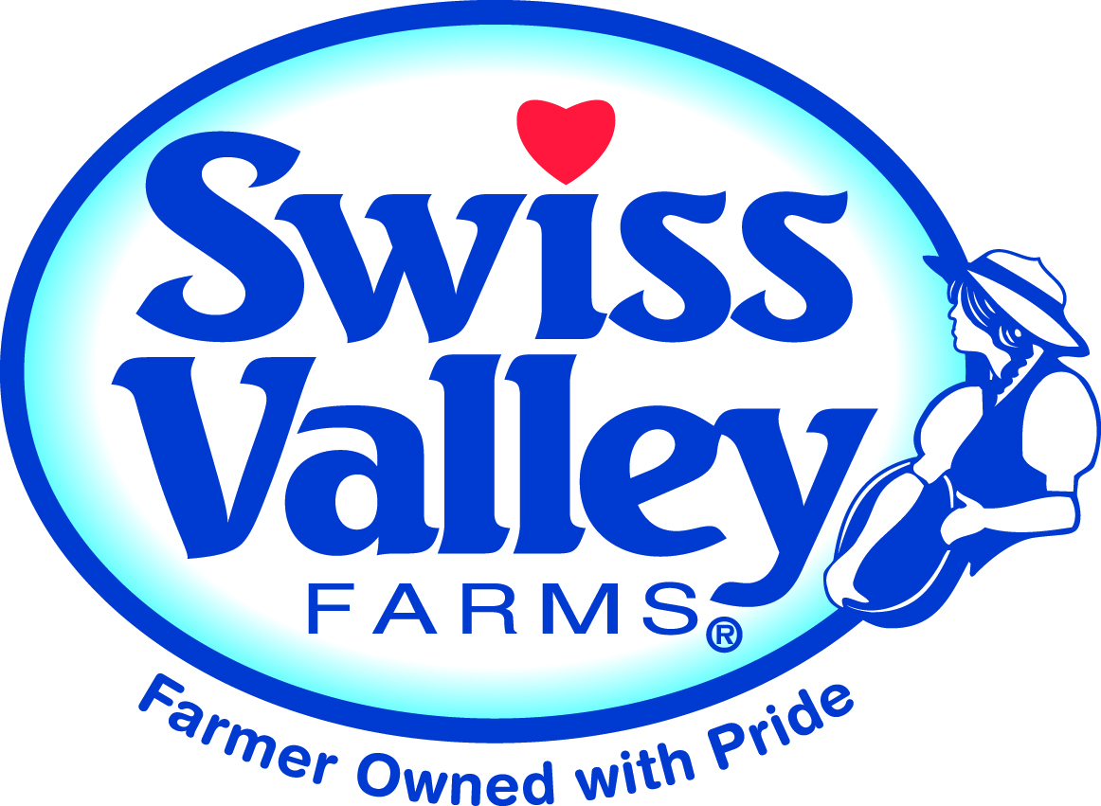

SWISS VALLEY FARMS
2017 Scholarship Application

Name: _____________________________________________________________________

Address:____________________________________________________________________

Phone: ____________________________ Date of birth: _________________________

E-Mail address:___________________________________________________

Please check one: My Major is: Agriculture-oriented □ or Another Field of Study □

Are you or your parents currently Swiss Valley Farms co-op members? _______________

What is your SVF producer number? ________________
Name and address of college, vocational or trade school you plan to attend full-time in the fall of 2017 and where this scholarship will be used:
__________________________________________________________________________

_________________________________________Expected major:___________________

From what high school did you graduate and in what year?

What will your grade classification be in the fall of 2017? ___________________________

1. What agricultural activities are you presently active in or have been active in? Describe your own supervised FFA ag program and/or 4-H experience. List dates of these activities. (Feel free to use a separate sheet)

__________________________________________________________________________

2. List any extra-curricular activities you were involved in while attending high school and secondary school. (Sports, band, etc.) List dates of your involvement.

3. List offices and leadership positions held in organizations such as church, school, community, FFA, 4-H, etc. (Include name of organization, year, office and duties)

4. Explain how you have contributed to being a Swiss Valley Farms co-op member, either directly or by helping out your parents, family or employer while they have participated in co-op-related activities.

5. Describe any jobs you have held off the farm.

6. On a separate sheet, explain your career goals and what motivated you to make that career selection.

Name of parents in full
and their phone numbers:

CERTIFICATION:
I hereby certify that the information contained in this report is true and correct to the best of my knowledge.
Signature of applicant: Date:

PLEASE NOTE: Scholarship checks will be distributed at the conclusion of the 2017 Fall semester after winning students submit their grade report to Swiss Valley Farms. A winner’s family must be Swiss Valley Farms co-op members at the time the scholarship check is distributed.

By signing below, I verify that I am a current Swiss Valley Farms member and that all the information contained in this report is true and correct to the best of my knowledge. If my son or daughter is selected to receive one of the scholarships, he/she has my permission to accept the award.
Signature of parent/guardian: Date:

Mail this application to:
Scholarship deadline is March 1, 2017 – postmark date
Swiss Valley Farms Cooperative - Scholarship Application
Nancy Feeney, Member Relations Manager
P.O. Box 4493, Davenport, IA 52808

Or e-mail application to: nancy.feeney@swissvalley.com
FAX: 563-468-6616 Be sure to e-mail Nancy Feeney before FAXing.

List the newspapers you would like a news release sent to if you win a scholarship.
_________________________________________________________________________________________
Previous scholarship winners are not eligible to apply again for this scholarship.

