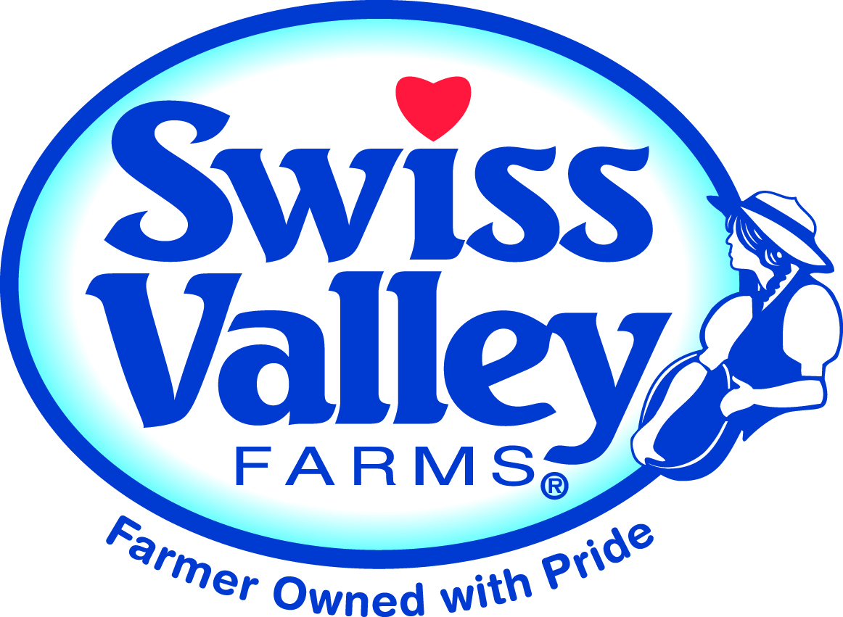

SWISS VALLEY FARMS
2014 Scholarship Application

Each year, Swiss Valley Farms Cooperative gives out two $1,000 and three $500 agriculture scholarships and three $500 scholarships for non-agriculture majors. Current Swiss Valley Farms members and their children are eligible to apply and receive these scholarships. If you have received one of these co-op scholarships in the past, you are ineligible to apply again.

Name: _____________________________________________________________________

Address:____________________________________________________________________

Phone: ____________________________ Date of birth: _________________________

E-Mail address:________________________________ Phone: ___________________

Are you or your parents currently Swiss Valley Farms co-op members? ______________________________

What is your SVF Producer Number? _______________________
Please check one: My Major is -- Agriculture-oriented □ or Another Field of Study □
List your expected major:____________________________________________________________________

Name and address of college, vocational or trade school where this scholarship will be used and you will be attending full-time this fall, taking a minimum of 12 credit hours:
______________________________________________________________________

From what high school did you graduate and in what year?

What will your grade classification in college be in the fall of 2013? ___________________________

- What types of agricultural activities are you presently active in or have been active in?
Describe your own supervised FFA ag program and/or 4-H experience. List dates
of these activities.

_________________________________________________________________________________________

2. List any extra-curricular activities you were involved in while attending high school and secondary school. (Sports, band, etc.) List dates of your involvement.

_________________________________________________________________________________________________________________________________________________________________________________

- List offices and leadership positions held in organizations such as church, school, community, FFA, 4-H, etc. (Include name of organization, year, office and duties).

4. Explain how you have contributed to being a Swiss Valley Farms co-op member, either directly or by helping out your parents, family or employer while they have been involved in co-op related activities.

5. Describe any jobs you have held off the farm.

6. ESSAY: On a separate sheet, explain your career goals and what motivated you to make that career selection.

Name of parents in full
and their phone numbers:

CERTIFICATION:
I hereby certify that the information contained in this report is true and correct to the best of my knowledge.
Signature of applicant: Date:

I verify that I am a current Swiss Valley Farms member and that all the information contained in this report is true and correct to the best of my knowledge. If my son or daughter is selected to receive one of the scholarships, he/she has my permission to accept the award. I also realize that I must be a current member of the co-op at the time the scholarship check is awarded.
Signature of parent/guardian: Date:

Mail this application to:
Scholarship deadline is March 31, 2014.
Swiss Valley Farms Cooperative - Scholarship Application
Nancy Feeney, Member Relations Manager
P.O. Box 4493, Davenport, IA 52808

List the newspapers you would like a news release sent to if you win a scholarship.

_________________________________________________________________________________________

